# theSource FAQs & Access Log In Troubleshooting Tips

theSource FAQs 1

Getting Started in theSource 1

theSource Access Troubleshooting 1

theSource Resources 1

**Description:** This document provides general information about theSource including how to get started and troubleshooting tips.

|  |
| --- |
| **theSource FAQs** |

1. **What is theSource?**

theSource is a comprehensive Knowledge Management Solution Operations colleagues. Colleagues utilize theSource to access work instructions, job aids, announcements, reference materials, talk tracks and much more.

1. **What does theSource include?**

theSource includes:

* A modern and powerful search engine
* An intuitive and custom designed user interface
* Exciting functions and features
* A modern content manager (Nuxeo) for our document publishers

1. **What are some of the features of theSource?**

* **Acknowledgments:** Part of your job responsibility is to remain informed of the changes occurring within your business area. When a document related to your role is updated, an acknowledgement is typically required to ensure you’ve read the new or edited information.
* **Subscriptions:** Subscribe to important documents you use regularly and get updates when they are changed and/or updated.
* **Personal Settings:** Set up your personal profile to ensure you only see information pertinent to your department and job.
* **Saved Searches:** Save an effective search that you conduct regularly to be more efficient the next time you need to perform it.
* **Document Compare:** The ability to see exactly what was changed from one revision or update of a document to the next.
* **Major vs. Minor Revisions:** An indication of the level of update to the document (changes in content vs. minor changes in formatting).
* **Browser Style Favorites:** Use Google Chrome Bookmarks to quickly bookmark your favorite documents with the ability to re-name, order and organize your bookmarks in custom folders.
* **Document Feedback:** Report specific issues with documents and provide feedback on what works well or what needs to be improved.

**4. What is the search experience like?**

theSource includes an “Elastic” search engine which is a modern and intuitive, user focused search engine that can power extremely fast searches against large volumes of data. This means that you will experience a search more like Google and Amazon.

**Here are some of theSource’s search specific features:**

* Powerful Advanced Full Text Search
* Data Facets (similar to how Amazon allows you to filter your search results)
* Dynamic Filtering
* Document Tagging

**5. What are Profile Settings?**

To help ensure you see and search for the most relevant information for your job, you can select all or any combination of Personal Settings values including: Business Area, Department, Line of Business, Position and Facility. In addition, you have the ability to set up a profile (a pre-defined set of personal settings) for the job you perform. If you perform more than one job, you have the ability to establish more than one profile and easily toggle between the two.

Each business area and department has determined what profile settings their department will use. These are outlined in detail for users in theSource. See [theSource - Profile Settings Reference Guide (Personal Settings) (017625)](https://thesource.cvshealth.com/nuxeo/thesource/#!/view?docid=d2e37c4f-7320-473f-95cb-cf06e42e8104) for more information.

Receiving the “spinning wheel” or “clocking” when performing a search can usually be resolved by one of the following steps before a call to IT is necessary:



* Set up a profile for the job you perform. Attempting to search without narrowing any of the Personal Setting’s values can cause the search feature to take an extended period to return results. See [theSource - Profile Settings Reference Guide (Personal Settings) (017625)](https://thesource.cvshealth.com/nuxeo/thesource/#!/view?docid=d2e37c4f-7320-473f-95cb-cf06e42e8104) for more information.
* Practical Tips to Avoid Risk of Intermittent System Clocking:
* Do not use the “Select all” option when establishing a Personal Profile as it increases the likelihood of intermittent system clocking.
* If you want to see everything for a category, make no selection. This results in the same outcomes as using “Select all” but with no risk of intermittent system clocking.
* If you have one job, it is best to have just a single Personal Profile established with specific selections for each category (Business Area, Department, Line of Business, Position, Facility).
* If appropriate for your job, make a selection for “Position” as part of your Personal Profile Setting.  Do not use “Select all.”
* If appropriate for your job, select for “Facility” as a part of your Personal Profile Setting. Do not use “Select all.”

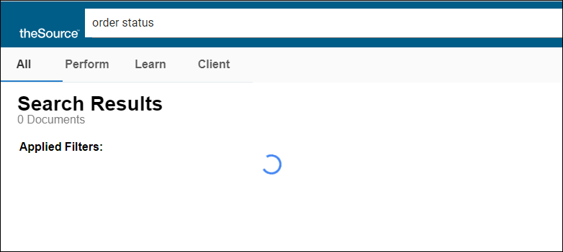

* Reset the profile you have created. See [theSource - Profile Settings Reference Guide (Personal Settings) (017625)](https://thesource.cvshealth.com/nuxeo/thesource/#!/view?docid=d2e37c4f-7320-473f-95cb-cf06e42e8104) for more information.
* Clear your computer’s cache. See [Clearing Your Cache (008655)](https://thesource.cvshealth.com/nuxeo/thesource/#!/view?docid=cd7acfcb-ad36-4da3-b973-faf08afb7dea) for more information.

**6. How can I learn even more about the features of theSource?**

In theSource search for and check out “theSource Feature User Guide”.

Top of the Document

|  |
| --- |
| **Getting Started in theSource** |

**1.** **How do I** **request access to theSource?**

* Go to Colleague Zone, search for “thesource” and select the IT Service Catalog item for “theSource Access”.
  + Or access the form directly with this link: <https://colleaguezone.cvs.com/cz?id=sc_cat_item&table=sc_cat_item&sys_id=3e5efbfe879931987a55baa8cebb3578>
* Fill out all fields in the form and submit.
  + **Note:**  The most common role code for colleagues to request is **TSRC-CSMR-1** = Standard CVS content access - Entry level front line user.
* Once manager and steward approvals are received, access is generally completed within 30 minutes.

**2. Is there Training?**

Yes, there is a 30-minute theSource self-paced Web Based Training module: [theSource - New Hire](https://cvshealth.sabacloud.com/Saba/Web_spf/NA10P1PRD006/common/leclassview/dowbt-0000521971)

**3. How do I log into theSource?**

Instructions on how to log into theSource are included as part of theSource Web Based Training Module.

**Log Into theSource:**

1. Open your Google Chrome browser.
2. Copy and paste this address into your Google Chrome browser - https://thesource.cvshealth.com/nuxeo/thesource
3. You may be automatically logged in. If not, on the login screen, enter your Windows/Network login ID and Password.

**4. I have read through this entire document, and I still have a question. How can I get my question answered?**

If your question was not addressed within this document, it can be sent to theSource Mailbox: [theSource@CVSHealth.com](mailto:theSource@CVSHealth.com)

Top of the Document

|  |
| --- |
| **theSource Access Troubleshooting** |

1. **What web browsers does theSource work with?**

theSource works best with Google Chrome version 50.0 or higher and that is the preferred browser. theSource is not recommended for use with Microsoft Edge.

1. **What ID Should I use to log in to theSource?**

* All users should log into theSource with their network/windows log in ID. This is the same ID that you would use to log in to the CVS Network.
* For vendors using the CaremarkRx domain, the network/windows ID is also known as the ZID.
* Colleagues that log into our CVS network with the prefix domain “CORP” may also refer to the network/windows ID as a “CORP ID”. These colleagues only need to use the network ID portion of that “CORP ID” and do not need to enter the prefix “CORP” when logging into theSource. For example, with **CORP/jsmith** only enter **jsmith** for theSource username.
* Regardless of domain, no domain prefix is required for logging into theSource. For example, for **CaremarkRx/jsmith** only enter **jsmith** for theSource username.

1. **What if I get the page below that says I don’t have access?**

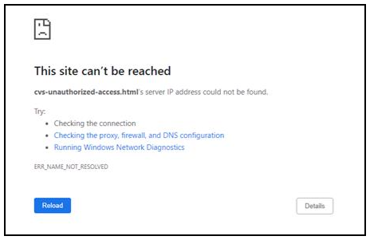

**You may have reached this page due to one of the following…**

**A Need to Clear Your Computer’s Cache:**

If you previously had access to theSource and you are now seeing this page, follow these steps:

* Clear browsing data/cache in Google Chrome. Details are available in the [Clearing your Cache (008655)](https://thesource.cvshealth.com/nuxeo/thesource/#!/view?docid=cd7acfcb-ad36-4da3-b973-faf08afb7dea) work instruction.
* After clearing the browsing data/cache, close all Google Chrome windows and then reopen.
* Copy and paste this address into your Google Chrome browser: https://thesource.cvshealth.com/nuxeo/thesource
* You may be automatically logged in. If not, on the login screen, enter your Windows/Network login ID and Password.

**No Access to theSource:**

You have not secured access to theSource.

* Requesting access is easy in Colleague Zone. Follow the steps above for **How do I request access to theSource?**

**Conflicting Role Codes:**

You may have been set up with role codes for theSource that are conflicting. If you suspect a recent role code change has resulted in your access issue, contact the IT Service Center to validate your role codes for theSource. If they are incorrect, submit a new access request in Colleague Zone for the appropriate role code(s).

Top of the Document

|  |
| --- |
| **theSource Resources** |

[Become a Certified theSource Wizard: Index (012793)](https://thesource.cvshealth.com/nuxeo/thesource/" \l "!/view?docid=729fd738-b7e2-4f20-8786-395b58bc2dc4)

[theSource- Feature User Guide (000828)](https://thesource.cvshealth.com/nuxeo/thesource/#!/view?docid=91d29dc8-0333-4222-9668-725dcb81305d)

Top of the Document

Not to be Reproduced or Disclosed to Others without Prior Written Approval

**ELECTRONIC DATA = OFFICIAL VERSION / PAPER COPY = INFORMATIONAL ONLY**